NAME: VENKATRAMAMOORTHY.G
- Write concise arrow functions.
CODE:
let square = x => x*x;
let add =(a,b) => a+b;
let greet =()=>'hello';
let createuser = (name,age)=>({name,age});
console.log(square(3));
console.log(add(4,6));
console.log(greet());
console.log(createuser('venkat',22));
OUTPUT:
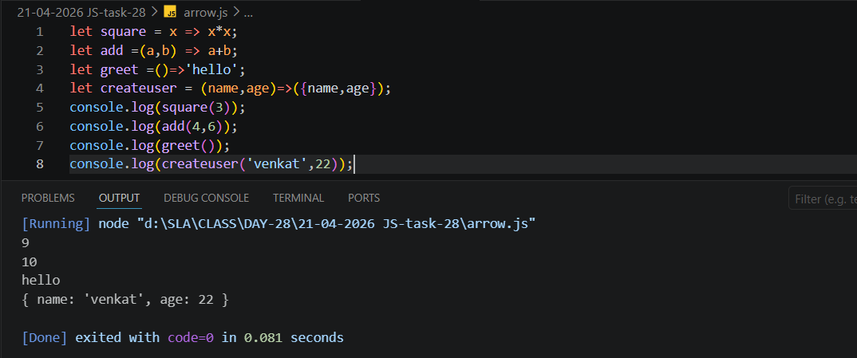
- Create a simple class with constructor and method.
CODE:
class vehicle{
constructor (name){
this.name=name;
}
display(){
console.log(`vehicle type :${this.name}`);
console.log('vehicle runing');
}
}
let bike= new vehicle('bike');
let car=new vehicle('car');
bike.display();
car.display();
OUTPUT:
